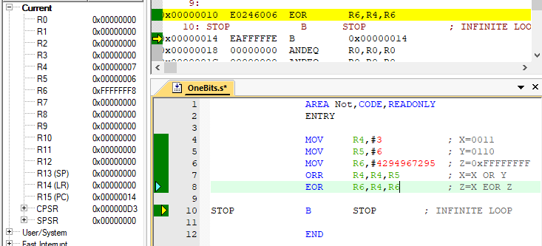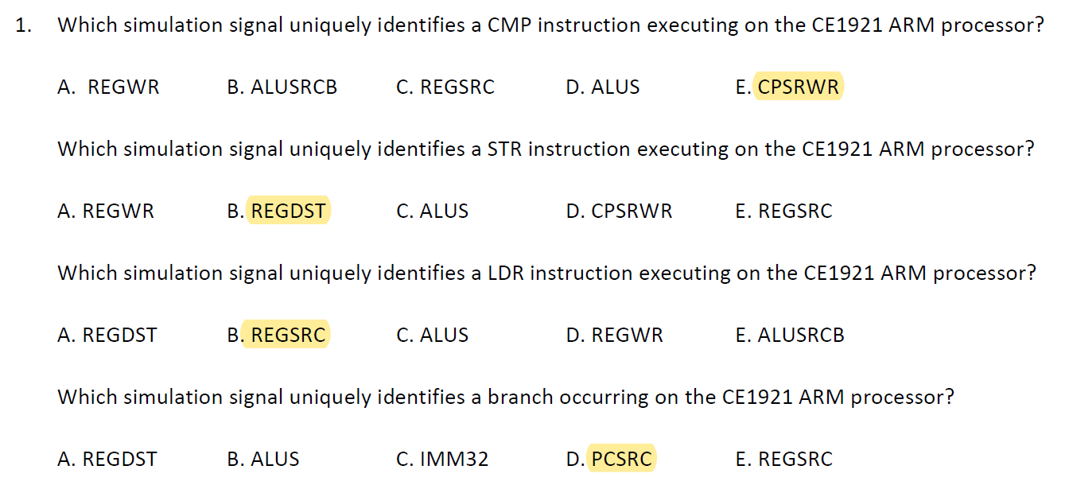

Hand Calculation: 0011 OR 0110 = 0111 0111 EOR 1111 = 1000 = 0xFFFFFFF8

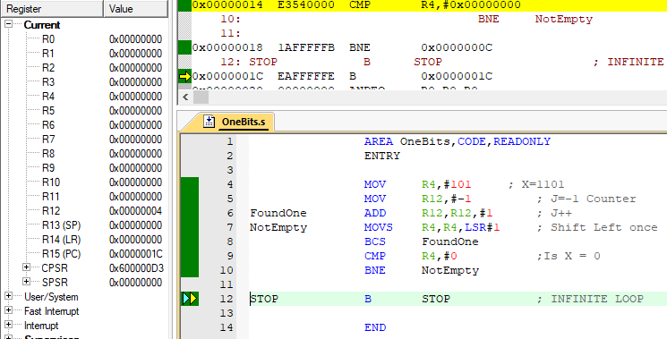

Decimal 101 is 0110 0101 has 4 one bits.